Singapore has a large economy and an even more enormous appetite, with many of our social and economic activities reliant on food. As such, our group wishes to uncover the magnitude of impact the country's economy places on its food industries and whether or not the already saturated market of Singapore's food industries can be held afloat or even accelerated by

upward-trending markets. We will compare a country's Gross Domestic Product (GDP) with the number of food industries in Singapore to see its growth or lack thereof compared to our economy. Highlighting how a country's macroeconomics affects (or lack thereof) its food industries.

Statement of the problem:

A growing GDP usually indicates a healthy and expanding economy. As GDP increases, there will also be an increase in consumers' disposable incomes and confidence, thus leading to more lavish spending on food.

However, there would be a problem if there is an increase in GDP but not the number of licensed food establishments, as that would indicate an oversaturation of the food commodity market, showing that there may be little to no room for growth in this sector. We are here today to find out how bright of a future this sector has for our economy.

Objectives of linear regression:

We will find out how Singapore's GDP affects the number of licensed food establishments.

Data Collection:

Let y = GDP of Singapore from 2008 to 2022

Let x = Number of Licensed Food Establishments from 2008 to 2022

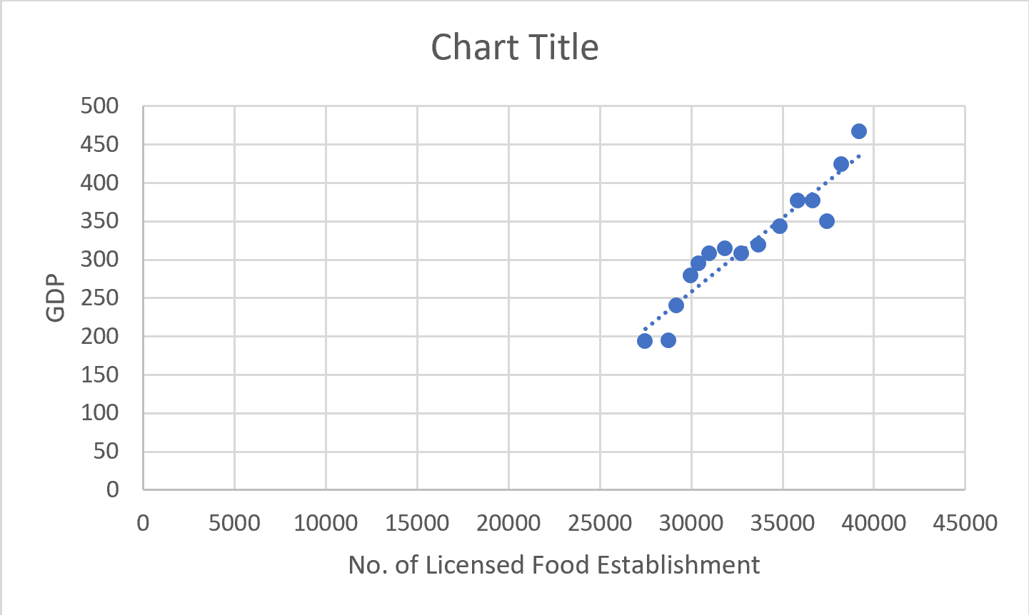  
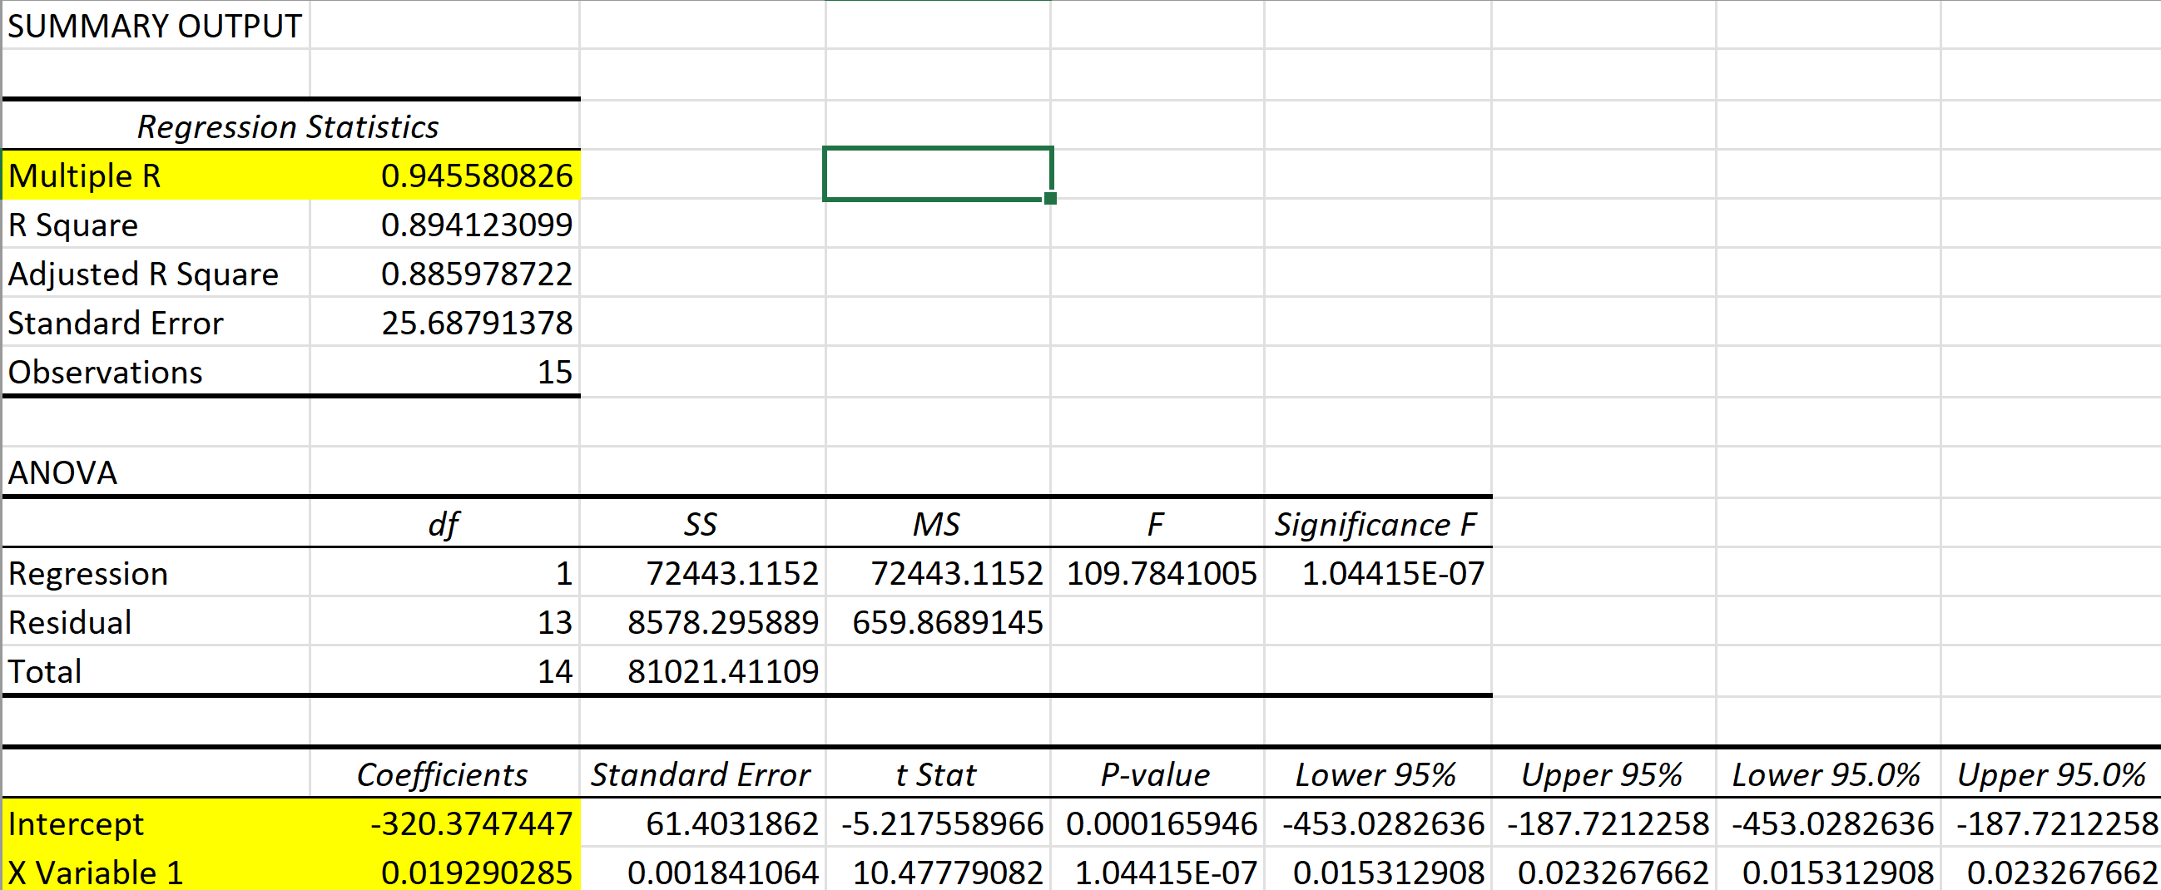  
  
For the summary output, the correlation coefficient r = 0.95(2d.p.). Therefore, a strong positive linear relationship exists between the GDP and the Number of Licensed Food Establishments.

The linear regression line is y = 0.019290285x + (-320.3747447)

The gradient has a positive value, which means there is a Positive Relationship between GDP and the Number of Licensed Food Establishments.

The Y-intercept shows that when X-Variable = 0, there are no Licensed Food Establishments. There will be a negative GDP of -320.3747447.

For Prediction, if in a certain year, the number of licensed food establishments has reached 70 000, using the regression equation.  
  
У = 0.019290285(70 000) + (-320.3747447) = 1029.945205 = 1029.95 BIllion USD (2d.p.)

Hence, there might be a total GDP of 1029.95 Billion USD for that particular year.

Linear regression models might assume that the relationship between GDP and the number of licensed food establishments is linear. This means that as GDP increases or decreases, the number of licensed food establishments increases or decreases. There are also limitations where a higher GDP does not necessarily cause an increase in the number of licensed food establishments. Other factors, such as population size, urbanisation, consumer preferences, government regulations, etc., also play a role.

Summary:

As Singapore's GDP increases, a strong positive correlation exists with the number of licensed food establishments. The correlation coefficient 0.95 (2 d.p.) indicates a solid relationship between GDP and the number of licensed food establishments. The positive gradient of 0.0193 (3 s.f.) supports the idea that as GDP rises, the number of licensed food establishments tends to increase. Economic growth creates an environment where entrepreneurs are more likely to establish licensed food establishments. The linear regression model also predicts that if licensed food establishments reach 70,000, the corresponding GDP would be approximately USD 1,029.94 Billion. Thus, the number of licensed food establishments is directly proportional to Singapore's GDP.  
  
Insights gained:   
We have found a definite correlation between the GDP of the country and its food industries, and we have learned that disposable income plays a gigantic role in the growth of even seemingly oversaturated industries like food. These findings can alleviate struggles in other countries. They could use this data as an example and focus on their economic strengths to increase food traffic into their country, giving nations facing food shortages a clear way out of their dilemma.  
  
Contributions

-Yijie was instrumental in calculating, compiling and processing our data sets provided, handling the regression, test statistics and data processing in Excel. Drawing useful information and performing error prevention in our work

-Liang ran calculations on the topic while also building on our conclusion through the information we acquired and was the one who oversaw data sourcing and functional fragmentation of information for summarising

-Qi Hang added to this by reviewing thoroughly, refining the quality of our data and calculations, and presenting it in the documentation. He also assisted with Yijie's regression calculations and acquired valuable data for processing while making sure our operations were following the assignments' rubrics